

**CS 255 Business Requirements Document Template**

Complete this template by replacing the bracketed text with the relevant information.

This template lays out all the different sections that you need to complete for Project One. Each section has guiding questions to prompt your thinking. These questions are meant to guide your initial responses to each area. You are encouraged to go beyond these questions using what you have learned in your readings. You will need to continually reference the interview transcript as you work to make sure that you are addressing your client’s needs. There is no required length for the final document. Instead the goal is to complete each section based on your client’s needs.

**Tip:** You should respond in a bulleted list for each section. This will make your thoughts easier to reference when you move into the design phase for Project Two. One starter bullet has been provided for you in each section, but you will need to add more.

**System Components and Design**

**Purpose**

The purpose of this system design is to provide a service for student drivers which will allow them to study for the written and on-the-road driving tests. The system will include online study materials and practice tests, and an appointment scheduler for students to schedule on-the-road practice.

**System Background**

* DriverPass wants the system to allow users to schedule on-the-road driving training appointments, including canceling and modifying said appointments
* DriverPass wants the system to allow the user to access learning content
* DriverPass wants the system to allow users to take practice tests, and the system should track progress on these practice tests for the user to review
* DriverPass wants the system to allow users to access their account online or offline (only online access will allow users to make any changes to information)
* DriverPass wants the system to allow IT admin to access all accounts (in case of forgotten password or in the event of an employee leaving and needing blocked access)
* DriverPass wants the system to allow Liam (big boss admin) to have access to all activity, and be able to download reports when needed
* The problem that DriverPass wants to address is that student drivers don’t have a reliable source to learn for driving exams. They want to provide a service that will provide students with up-to-date information from the DMV, access to learning materials and content, and a way to schedule in-person trainings with driving teachers
* The different components needed include:
  + A scheduling system for in-person driving training
  + Practice exams with progress reports for students to review
  + Learning content for students to study
  + Activity reports for admin to download and review

**Objectives and Goals**

* This system needs to:
  + be able to perform appropriately without bugs, without undue loading/buffering, and without security concerns
  + allow each user to log in to a unique, personal account
  + provide access to learning content and practice exams dependent on the package selected by the user
  + provide every user with access to the scheduling system and should allow users to schedule on-the-road training dependent on the package selected
  + regulate the scheduling system in accordance with how many cars/drivers are available at any given moment (10 cars with 1 driver each)
    - No more than 10 appointments can be schedule in any time slot
    - Each time slot is 2 hours long, once a driver is assigned to a student that driver can not be booked again within the 2 hour time slot
* The measurable task which need to be included are:
  + Can unique accounts be created and accessed with respective username and password
  + Verify if test accounts which have purchased different packages have access to learning content, or can schedule the appropriate amount of classes (Package One: 6 hours, 3 classes. Package Two: 8 hours, 4 classes. Package Three: 12 hours, 6 classes)
  + Verify that the scheduling system will not allow more than 10 appointments for any given time slot
  + Verify that the scheduling system does not allow the same car/driver to be scheduled for the same time slot
  + Verify that each time slot is set for 2 hours
  + Verify that users can not modify information in their account when offline
* DriverPass has also included a sketch of the ideal homepage layout

**Requirements**

**Nonfunctional Requirements**

**Performance Requirements**

DriverPass needs the system to be run using the cloud, therefore it must be web-based. The system must load within 3 seconds on a desktop or 9 seconds on a mobile device (Das, 2023). The system must be updated in accordance with any DMV policy, rules, or practice question updates. Additionally, the system will need to be updated should DriverPass change any package offerings or content.

**Platform Constraints**

DriverPass requires the use of a cloud to avoid dealing with backup and security, therefore the system will run on a cloud-based platform. The best option for a cloud-based platform is Amazon Web Service (AWS), because it has the broadest range of availability, offers various database storage options, and is widely considered to be the best in reliability and security (Wickramasinghe, 2021).

**Accuracy and Precision**

Different users will be distinguished as either administrator or customer, then customers will be distinguished by the package chosen. Package 1 and 2 only include on-the-road training, so customers using these packages will only have access to the scheduling system. The customers which chose Package 3 will have access to the scheduling system and the learning content. The administrators will have access to the scheduling system, learning content, and other user profiles. The input will be case-sensitive for passwords. The system will inform the administrators of a problem as it occurs.

**Adaptability**

The administrators can make changes to a user without modifying the code, there will be profile edit mode accessible by both the user and the administrators. A user can be granted access and have it revoked by another administrator (upon hire or fire or as needed). The system will need to undergo an update in order to adapt to any platform updates, though some platform updates may not have any effect on performance. IT will need access to everything, level of access can be restricted based on the position where the IT officer (Ian) has the ability to access and modify anything on the website, whereas an entry level IT administrator can only access but not delete profiles or content.

**Security**

The user will need their username (email) and password (case-sensitive) to login, two-factor authentication can be implemented to ensure security. Amazon Web Service offers a virtual private network (called Virtual Private Cloud) which can be used by administrators to secure connection. For the customers the web pages will use a Secure Sockets Layer (SSL) to ensure a secure connection. In the event of a brute force hacking event the account can be flagged and temporarily closed (or frozen) by the system. This will require the customer to reach out to the administrators who will help the customer regain access and further secure their account. There will be two-factor authentication and security questions which will allow the users to regain access to their account in the event of a forgotten password.

**Functional Requirements**

* The system shall validate user credentials when logging in.
* The system shall display the scheduling calendar to the user when accessing the appointments page.
* The system shall

**User Interface**

* The system should display a landing page for all users, not logged in, and prompt for login or create an account.
  + The system should allow users to create a new, unique account using email address as username.
  + The system should require users to add two-factor authentication and security questions when creating an account.
  + The system should allow the user to update profile information, including two-factor authentication options and security questions, by entering password.
* The system should proceed to a logged in landing page (drafted by DriverPass) once the user logs in.
  + The system should block access to learning content for users that have not purchased the package containing online content (package 3).
    - The system should require a unique key, generated upon purchase, to access learning content.
* The user can review previous test scores, take practice tests, update profile information, view driver’s notes, and access support.
* The administrative users should be able to access each component of the system and add, modify, or delete as needed.
  + User access should be limited according to account security level.
* The system should send notifications to users upon scheduling a driving lesson.
  + The system may also allow parents to add a parent email, to which the system can send additional notifications for appointment scheduling.
* The system should send a notification to administrators when an error occurs.
* The users can access the system via mobile browser or desktop.

**Assumptions**

* It is assumed that each user is using technology updated to at least the third most recent browser, of any major internet browser.

**Limitations**

* The system is limited by the size of the company.
  + DriverPass can’t be in charge of backup and security, therefore the system will be run on a cloud based platform.
  + The cloud based platform will have its own limitations, like compatible browsers, depending on which is chosen.
* The system is limited by the ability of the administrators.
  + DriverPass will need to reach out again, or to another firm, in order to update certain aspects of the system.

**Gantt Chart**

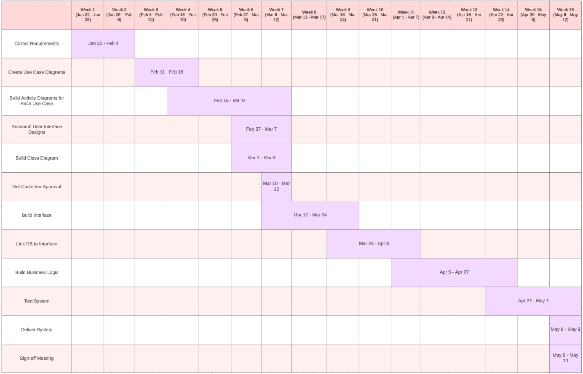

*Large version next page.*

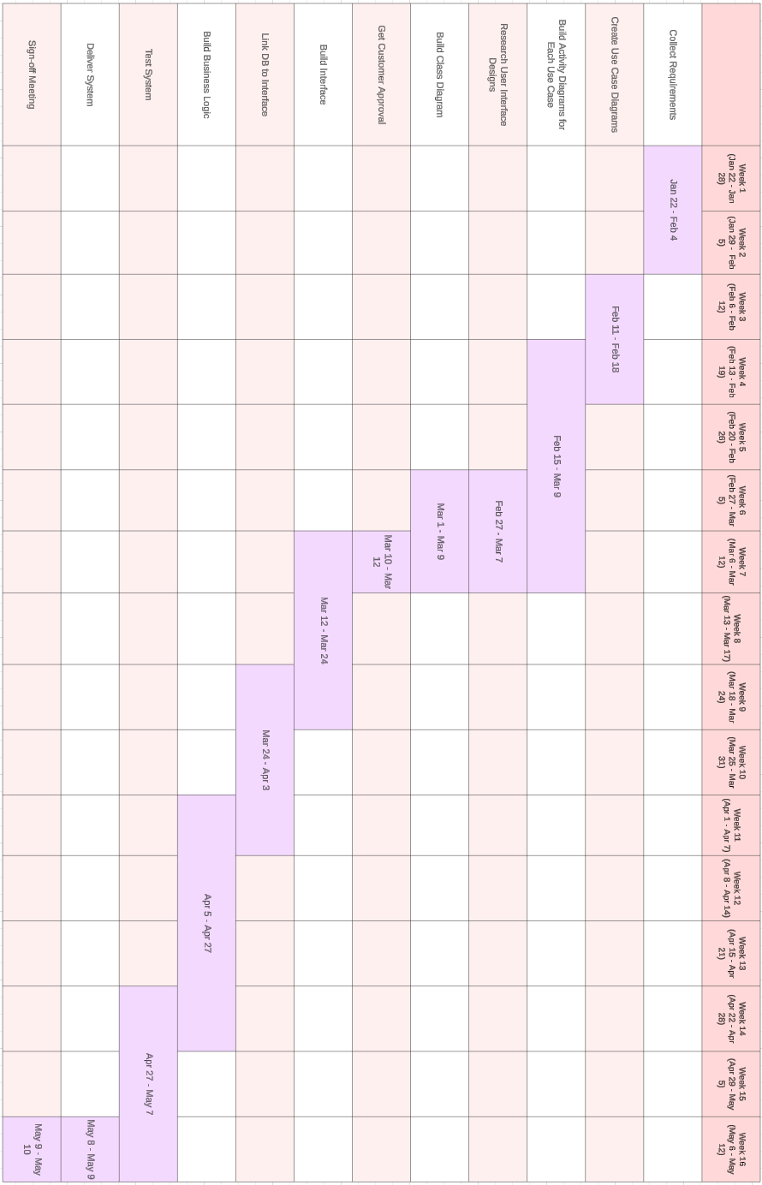

**References**

Das, S. (2023, April 6). *How fast should a website load in 2023?* BrowserStack. https://www.browserstack.com/guide/how-fast-should-a-website-load

Riley, M. (2023, October 4). *How Often Should You Update Website Content to Maintain Rankings? (Best Practices Past Results)*. Grow and Convert. https://www.growandconvert.com/content-marketing/how-often-should-website-content-be-updated/

*What is an SSL Certificate?* (n.d.). DigiCert.com. https://www.digicert.com/what-is-an-ssl-certificate

Wickramasinghe, S. (2021, October 1). *AWS vs Azure vs GCP: Comparing The Big 3 Cloud Platforms*. BMC Software. https://www.bmc.com/blogs/aws-vs-azure-vs-google-cloud-platforms/